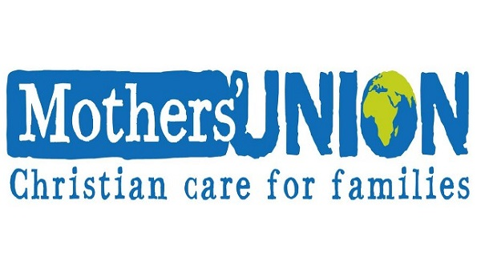


The Diocese of Lincoln

SPRING 2022

A New Diocesan President for Mothers Union in
the Diocese of Lincoln
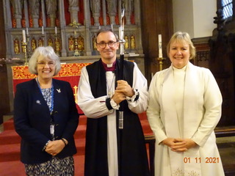

The Bishop of Grantham commissioned our new Diocesan President, Trustees and Postholders at a wonderful service in St Peter at Gowts Church in Lincoln.
We had the Diocesan Banner there and our hymns were accompanied by our new MUzic group.
Bishop Nicholas encouraged our membership and showed he was proud and inspired by all MU does in the diocese and worldwide.
We begin a new Triennium with great joy and hope of spreading the Good News of Christ through our work and prayers of MU in our branches, clusters and amongst our growing number of Diocesan Members.
Our new Diocesan President is The Revd Sylvia Rice-Oxley who is a retired priest. Along with her husband Richard, also a retired priest, she hopes to encourage the work of MU in the diocese and build up membership. One of her aims is to inform and aid clergy and lay ministers in the work and value of MU, with the guidance of our Diocesan Chaplain, Revd Carolyn Bailey. Sylvia also hopes to visit branches and clusters as well as meeting with Diocesan Members.
We are grateful for the great work which Elizabeth Page did during the last 6 years as Diocesan President.
Elizabeth is continuing to support Lincoln Diocese as Administrator, for which we are very thankful.
Everyone is welcome to join us in our activities and we welcome suggestions of new ministry and ways of doing and being MU in our beloved Diocese.

From your Diocesan President
The Revd Sylvia Rice-Oxley
My dear friends,
This is my first letter to you as Diocesan President and it comes with much love and thanks for your membership and for the work you do for God. I am immensely proud of Mothers’ Union in Lincoln Diocese. We are part of a worldwide movement of faith and change. Many lives are being changed in our own communities and in many countries around the world because of Mothers’ Union Members. May God continue to inspire and bless our work.

All over our Diocese we worship and celebrate special occasions locally - Mothering Sunday, Lady Day, Mary Sumner Day, to name but a few, and no doubt members will be involved in celebrating our beloved Queen’s Platinum Jubilee in June.
We also get together as a Diocese and I hope you might be able to come to our Summer Council on Saturday 25 June when we hope to have a real members’ day, and Winter Council on Monday 14 November when Bishop Nicholas will be with us.
As we had to postpone MUzic Day, I am inviting Diocesan Members to a zoom coffee and chat 10-11am on Saturday 7th May. It will be lovely to meet with you then and I hope that Trustees and officers of the Diocese will be drinking coffee with us! The link will be sent out later on.
On 19th July we are holding a lunch for clergy and lay ministers in the Diocese at Washingborough Community Centre and hope that this will be an opportunity to share our great resources and demonstrate what a great resource we can be to our churches.
Please support this by inviting your ministers to join us then.
Our Chaplain, Revd Carolyn Bailey and our Faith Co-ordinator, Kate Brown, are organising our Annual Retreat on 13 October at Bishop Grosseteste College in Lincoln. The Revd Richard Steele, who worked in mission and outreach in this Diocese, will lead us as we think about being transformational.
We have been launched into Facebook! Mothers’ Union Lincoln now has a Facebook page thanks to our Chaplain, Carolyn. Please support this by sending her pictures and articles of past, pleasant and future events and news. lincolnmuchaplain@gmail.com

Welcome to Bishop Stephen
On your behalf I sent a word of welcome to Bishop Stephen to which he sent a prompt and lovely personal reply. He remembered my husband when they were both vicars of parishes in Darlington!
What a small world.
Bishop Stephen is a keen member of Mothers’ Union and wrote:
“I am delighted that Bishop Nicholas provides such good support for the Lincoln Mothers’ Union.
I join him in offering heartfelt support for your ministry and encouragement across the diocese”.
We continue to pray for Bishop Stephen and all our leaders that together we may be the people God wants us to be in this beautiful Diocese of Lincoln.
We are grateful to Revd Ian Robinson for editing this Newsletter and I hope you will continue to support this wonderful way of showing the life of MU Lincoln Diocese.
I look forward in the next few months to meeting with many members as I visit Branches and Clusters, as well as Diocesan events, and I am happy to have more events booked into my diary, however large or small!

With love and prayers,
Sylvia - Diocesan President (dpmulincoln@gmail.com)

From our Chaplain

Hello Everyone
I thought this would be a good opportunity to say hello and introduce myself, I am Carolyn Bailey and I am your new president Sylvia Rice Oxley’s Chaplain. If you are wondering what that involves,
believe me I am also working out what it involves!
What I do know is that through prayer and get togethers I am here to support Sylvia as she takes on this exciting new role. We are both aware that all of this will take place around my role as rector f three parishes in South Lincolnshire.
I would like to let you know what I have been up to and to share the things we have to look forward to.
Firstly, I would like to thank Sylvia and Elizabeth for their support and acknowledgement that I need some flexibility and allowing to ‘do what I can and not what I can’t’. This flexibility will allow all of us to offer what we are able in the months and years ahead.
I would like to share the launch of the Lincoln Diocese Mothers’ Union Facebook page,
https://www.facebook.com/MothersUnionLN2
So many people use Facebook to share news and it will be a great way of raising our profile. However, this can only happen if we have news to post on it. If you do not use FB there are many who do, so please send you thoughts and photos to me and I can post them for you at lincolnmuchaplain@gmail.com
On the 19th July we are holding a lunch for the clergy in the Diocese. We are holding this in Washingborough Community Centre and hope that this will be an opportunity to share our great resources and demonstrate what a great resource we can be to our churches, to the ministers in our wonderful Diocese, so watch this space and we will let you know how it goes!
On 13th October we will be holding a day retreat and we are looking forward to welcoming Richard Steel to come along and lead us as we think about being transformational. This is subject is close to Richard’s heart as he worked in mission and outreach for the Diocese, again once we have more details we will be letting you know, but perhaps you could do a save the date!
We have our Summer Council meeting and in November our winter council meeting will have Bishop Nicholas celebrating with us.
There is a lot happening as our branches open up and start meeting again.
I am busy but please do not let this put you off inviting me along to say hello. If I cannot manage it I will let you know but please don’t assume I am always too busy!
I look forward to meeting some of you soon.
Carolyn

The Mothers’ Union Prayer
Loving Lord,
We thank you for your love so freely given to us all.
We pray for families around the world.
Bless the work of the Mothers’ Union as we seek to share your love through the encouragement, strengthening and support of marriage and family life.
Empowered by your Spirit, may we be united in prayer and worship, and in love and service reach out as your hands across the world.
In Jesus’ name.
Amen

The Prayer of Mary Sumner, founder of Mothers’ Union
All this day, O Lord,
let me touch as many lives as possible for thee;
and every life I touch,
do thou by thy spirit quicken,
whether through the word I speak,
the prayer I breathe,
or the life I live.
Amen

Pinchbeck celebrates 100 years of MU!
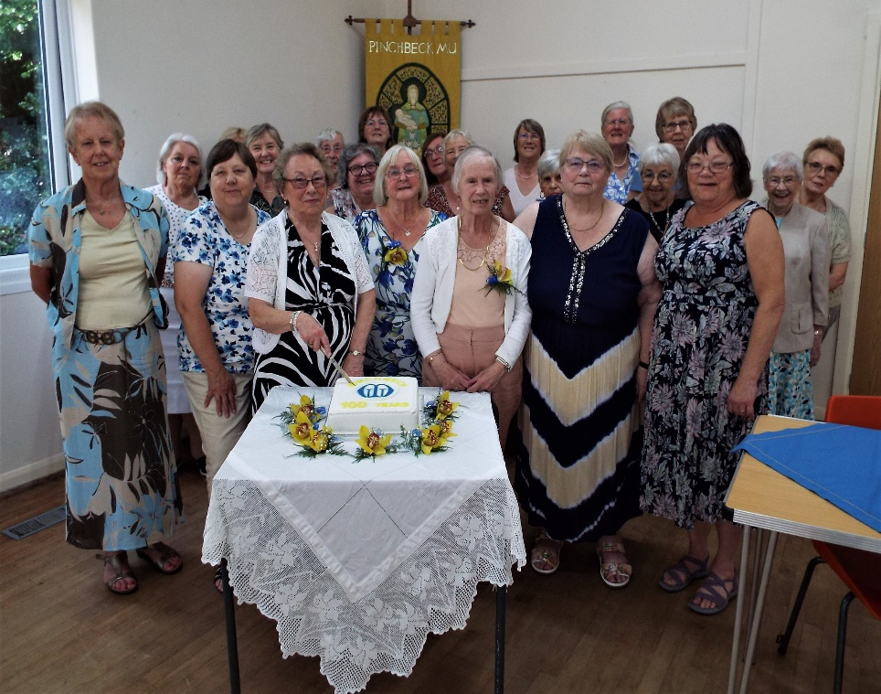

In September last year Pinchbeck St Mary's Mothers' Union celebrated the Centenary 100 years 1921 --2021 with a lunch in the Church Hall. The toast was given by leader Janet Bettinson and a delicious meal was enjoyed by all.
A short service took place, the one that was especially written for Mary Sumner Day Service celebrating 145 years since the movement began. On display were very many past Minute books, programmes and photographs from the past bringing back many memories. The celebratory cake made and iced by Tracey was cut by retiring Treasurer of 40 years Alma Nicholls
We had sad news in January when we stood in silence remembering Jose Bray, a very loyal and long-standing member of our branch who will be sadly missed having passed away.
Rainbows Hospice making every moment matter!
Rainbows helps families make the most of every precious moment, while capturing memories and keepsakes to treasure. It provides care and support for 300 children and young people with life-limiting and life-threatening conditions, and their whole family, across the East Midlands. The care Rainbows offers is wide ranging; palliative care and end of life care, symptom management, emergency care, respite and short breaks and is available in the hospice, at home and in hospitals. The charity offers comfort and compassion during tough times, provides the highest level of professional care until the end, and support after. Simply put, Rainbows is there to brighten short lives, and support families. It costs over £6 million a year to run the hospice and its services, and relies on the support of its fundraisers.
Rainbows is the East Midlands only hospice for children and young people with life limiting and life-threatening conditions. If you are interested in finding out more about Rainbows please get in touch with Kirsty the community fundraising for Lincolnshire and Nottinghamshire.
She can even come along to one of your group meetings and provide an informative and moving talk about the work of Rainbows and how our service offers vital care and support to local families. Rainbows is a hospice but we are also much more than that, have a chance to listen to inspiring stories about how Rainbow began, our amazing staff and families. Talks can be catered to suit you and your great. Please get in touch to have a chat and find out more. Kirsty Coxon 01509 638 061 kirsty.coxon@rainbows.co.uk

Thimbleby with Horncastle Branch welcome new members!
At our Annual General Meeting in January, 3 new members were enrolled.
We are planning a service for Lady Day to be held at 2.00 p.m. at St Mary’s Horncastle. Our curate. The Revd. Lynne Hawkins, is helping with the organisation of the service. She is to be enrolled as a MU member at this service. We are fortunate that the Priest in Charge of the Asterby Group is a MU member so she is also assisting in the service. The speaker will be The Revd. Margaret Done from Coningsby who is the mother of our curate.
We have only one other branch in our cluster, Woodhall Spa, and they are joining us on Lady Day and the Rural Dean is inviting other churches in the Deanery to join us on this important day, bringing any banners from former branches.
Veta Jay, Branch Leader.

An invitation to our clergy
Please make your clergy aware of a
special invitation!
On
19th July 2022
At the Washingborough Community Centre
10 Fen Road
Washingborough
LN4 1AB
There will be a buffet lunch from 12 to 2pm

Why?
Because we want our clergy to discover who we are, what we do and introduce them to the great resources we have available for them and our church.

RSVP by July 1st
Rev’d Carolyn Bailey lincolnmuchaplain@gmail.com

Theme for 2022: Transformation Now!
Meetings and Events 2022
Postponed 12-4pm Saturday 7 May Music Workshop Day at Bourne

10-11am Saturday 7 May by zoom
Diocesan Members Get-together with your Diocesan President

10am Monday 16 May by zoom Trustee and Officers Meeting

12-2pm Tuesday 19 July Clergy and Lay Ministers Lunch at
Washingborough Community Hall

10 am Monday 12 September by zoom Trustee and Officers
Meeting

10.30 - 3pm Thursday 13 October Retreat at Bishop Grosseteste
College

10.30am Monday 14 November
Winter Council & Celebration Eucharist with Bishop Nicholas at
St Peter at Gowts

3pm Wednesday 14 December
Carol Service by zoom

Other Events arranged locally
Friday 3rd June ff HM The Queen’s Platinum Jubilee
Tuesday 9th August Mary Sumner Day
10-16 October Prisons Week of Prayer
18th October Slavery Day
16-18 November Wave of Prayer
25 Nov-10 December Days of Activism against Gender Violence + Global Day

Diocesan Members - meet your new MU Officers 10-11am by zoom on Saturday 7th May. Link to be sent nearer the time.

Summer Council - Please join us for a Diocesan Get-together on Saturday 25 June 10-30am-3pm packed with information and fun including a Celebration Service led by our Chaplain and ending with afternoon tea.
Speakers’ List
Bishop of Grantham - Lady Day.
Diocesan President, Revd Sylvia Rice-Oxley - Diocesan vision,
annual theme, services and meetings
Diocesan Chaplain, Revd Carolyn Bailie - Lady Day,
Mary Sumner Day, branch/cluster meetings.
Diocesan Faith Coordinator, Kate Brown - Christian Maze,
Lent reflections, Godly Play, St Guthlac, OT Women bible studies,
MUzic Revd Richard Rice-Oxley
Elizabeth Page - MULOA
Patsy Moore
Sue Kerridge - Reimagining MU, Diocesan Members’ Fellowship Groups
Rainbows Hospice - Kirsty Coxon 01509 638 061
kirsty.coxon@rainbows.co.uk

A Prayer for Ukraine
Holy and Gracious God
We pray for the people of Ukraine and the people of Russia;
for their countries and their leaders.
We pray for all those who are afraid; that your everlasting arms hold them in this time of great fear.
We pray for all those who have the power over life and death; that they will choose for all people life, and life in all its fullness.
We pray for those who choose war; that they will remember that you direct your people to turn our swords into ploughshares and seek for peace.
We pray for leaders on the world stage; that they are inspired by the wisdom and courage of Christ.
Above all, Lord, today we pray for peace for Ukraine.
And we ask this in the name of your blessed Son.
Amen

Contacts
Diocesan President: The Revd Sylvia Rice-Oxley dpmulincoln@gmail.com
Diocesan Administrator: Elizabeth Page
ldmu1100@gmail.com
Diocesan Chaplain: The Revd Carolyn Bailey
lincolnmuchaplain@gmail.com
Diocesan Faith Co-ordinator: Kate Brown
kabstg@btinternet.com
Diocesan Members: Jenni Honisett:
dandjhonisett@btinternet.com
Diocesan Fellowship and Reimaginining MU: Sue Kerridge kerridge.sue@gmail.com
MULive: Mary Brown
m.brown2345@yahoo.com
Safeguarding: Christine Jackson
christinejackson1@btinternet.com
Diocesan AFIA Representative: Lisa Thomas
cthomas713@btinternet.com
MSH website and Data : Cathie
Whenmancathie.whenman@hotmail.com

Our next Newsletter
I hope to produce the next newsletter shortly before the Summer Holidays. — after the Summer Council and, possibly, after the Clergy Lunch.

Any items gratefully received: -
My email is: - revianrobinson@tiscali.co.uk

Or by post to: -
Canon Ian Robinson
Caistor Vicarage,
3, Spa Top,
Caistor,
Lincolnshire
LN7 6RB

