**September Reflection**

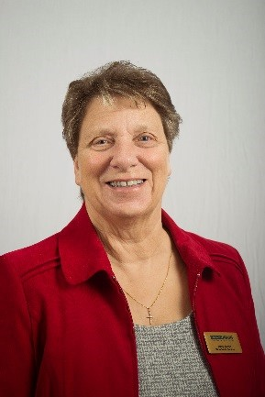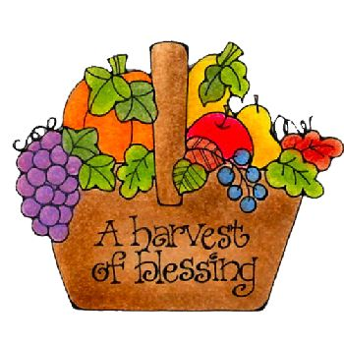Dear Friends,

How good it is to touch base with you once more. It sometimes doesn’t seem possible that we have now reached September, the season of mists and mellow fruitfulness is here once more. This is the time to wonder at the beauty of God’s creation and celebrate all that is provided from his bounty.

At this time of year, I am fortunate enough to be able to walk out into the garden and pick, beans, onions, tomatoes, apples, pears and blackberries. A rich harvest indeed, time to care and share as well as store carefully so that I will be able to benefit from this bounty through the months ahead.

One of the hymns I enjoy is: - *give thanks with a grateful heart, give thanks to the Holy One, give thanks because He’s given Jesus Christ His Son. And now let the weak say I am strong, let the poor say I am rich, because of what the Lord has done for us. give thanks.*

Hopefully most of us will be able to have some sort of Harvest celebration in church this year so that we can give thanks, even if this may be different from that which we are used to. We must never forget of course that many people are still suffering from hunger, so it is even more important to give, as best we are able, to the many food banks that are still very much needed. This is so much part of the work that Mary Sumner set out to do.

Even as we praise God for all his goodness and look in awe at his creation let us not forget, that this is a very difficult time for the Mothers’ Union and the members of staff at Mary Sumner House. Dedicated workers and MU members of staff have had to accept either voluntary of compulsory redundancy, because the charity can no longer support all the paid staff, despite the generosity of all the members worldwide, who gave so generously to the appeal.

This loosing of staff has caused much heartache, and your prayers are needed for the Trustee Board and our Worldwide President, Sheran, who, together with the Senior Leadership Team, has had to take this very tough decision.

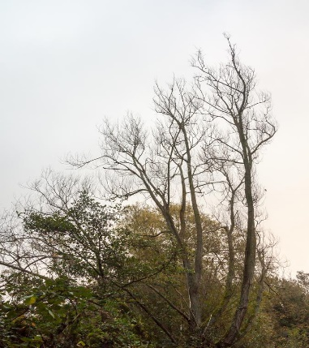As the Autumn colours begin to make themselves known we must never forget the beauty of the Lord and His goodness, and trust that He will enable all affected to move forward in faith into the new challenges that lay ahead.

In the autumn, I think we see our Heavenly Fathers generous heart more clearly than at any other time. The splendour of the autumn colours shows his glory and his loving care. September, as the leaves begin to fall, enables us to see the bare bones of his creation, the arms outstretched to hold us and support us, especially in these challenging times with covid19 still here, if hopefully, in the background.

It has been good for me to be able to get out and about and mix with a few more people and I hope it has been the same for you too.

So as life begins to take on a new norm let us embrace all that the world has to offer, even if that world is not very big, let us give thanks for the relationships of family, friends and all who care for us.

If you are unable to get out, I pray that you will be able to have relations or maybe even friends come to visit and will at least be able to look through a window at God’s creation. If like me you are fortunate enough to go for a walk in a park, take your time and drink in all that is surrounding you because God’s world is full of so many little things, we can all miss if we don’t keep our eyes wide open.

Please keep safe and well.

Love Jenny

**Let us pray**

*Loving Lord,*

*Help us to be fruitful in our work for Mothers’ Union. To grow initiatives that bring hope to the vulnerable and the downhearted, bringing new life where there is often despair.* *Amen*

(from Families Worldwide)